Name : Sejal Pawar

Class : Msc . Computer science ( Part 1 )

Rollno : 504

Subject : Social Network Analysis

Topic : Sentiment Analysis Program

# Social Network Analysis

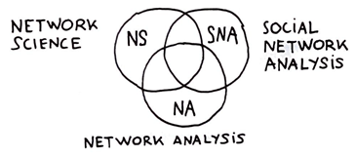

Social network analysis (SNA) is a process of quantitative and qualitative analysis of a social network. SNA measures and maps the flow of relationships and relationship changes between knowledge-possessing entities. Simple and complex entities include websites, computers, animals, humans, groups, organizations and nations.  
  
The SNA structure is made up of node entities, such as humans, and ties, such as relationships. The advent of modern thought and computing facilitated a gradual evolution of the social networking concept in the form of highly complex, graph-based networks with many types of nodes and ties. These networks are the key to procedures and initiatives involving problem solving, administration and operations.

# Sentiment Analysis

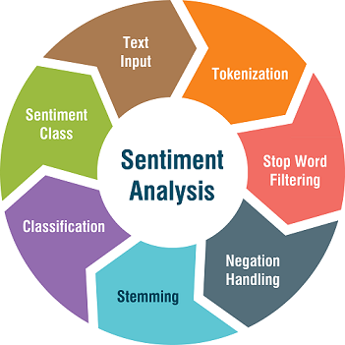

Sentiment analysis is the process of classifying whether a block of text is positive, negative, or, neutral. Sentiment analysis is contextual mining of words which indicates the social sentiment of a brand and also helps the business to

determine whether the product which they are manufacturing is going to make a demand in the market or not. The goal which Sentiment analysis tries to gain is to analyze people’s opinion in a way that it can help the businesses expand. It focuses not only on polarity (positive, negative & neutral) but also on emotions (happy, sad, angry, etc.). It uses various Natural Language Processing algorithms such as Rule-based, Automatic, and Hybrid.



### **Why perform Sentiment Analysis?**

According to the survey,80% of the world’s data is unstructured. The data needs to be analyzed and be in a structured manner whether it is in the form of emails, texts, documents, articles, and many more.

1. Sentiment Analysis is required as it stores data in an efficient, cost-friendly.
2. Sentiment analysis solves real-time issues and can help you solve all the real-time scenarios.

# Source Code ( Jupyter Notebook )

#!/usr/bin/env python

# coding: utf-8

# # 504 Sejal Pawar SNA mini project sentiment analysis

# # 1. Install and Import Dependencies

#get_ipython().system('pip install torch==1.8.1+cu111 torchvision==0.9.1+cu111 torchaudio===0.8.1 -f https://download.pytorch.org/whl/torch_stable.html')

#get_ipython().system('pip install transformers requests beautifulsoup4 pandas numpy')

from transformers import AutoTokenizer, AutoModelForSequenceClassification

import torch

import requests

from bs4 import BeautifulSoup

import re

# # 2. Instantiate Model

tokenizer = AutoTokenizer.from_pretrained('nlptown/bert-base-multilingual-uncased-sentiment')

model = AutoModelForSequenceClassification.from_pretrained('nlptown/bert-base-multilingual-uncased-sentiment')

# # 3. Encode and Calculate Sentiment

tokens = tokenizer.encode('It was good but couldve been better. Great', return_tensors='pt')

result = model(tokens)

result.logits

int(torch.argmax(result.logits))+1

# # 4. Collect Reviews

r = requests.get('https://www.yelp.com/biz/social-brew-cafe-pyrmont')

soup = BeautifulSoup(r.text, 'html.parser')

regex = re.compile('.*comment.*')

results = soup.find_all('p', {'class':regex})

reviews = [result.text for result in results]

reviews

# # 5. Load Reviews into DataFrame and Score

import numpy as np

import pandas as pd

df = pd.DataFrame(np.array(reviews), columns=['review'])

df['review'].iloc[0]

def sentiment_score(review):

tokens = tokenizer.encode(review, return_tensors='pt')

result = model(tokens)

return int(torch.argmax(result.logits))+1

sentiment_score(df['review'].iloc[1])

df['sentiment'] = df['review'].apply(lambda x: sentiment_score(x[:512]))

df

df['review'].iloc[3]

# Screenshot of program with output

( jupyter notebook )

